**Name :-Rahul pal**

**CourseName :-Cloud Computing**

**Course Code:-CA5EL50**

**Subjective Assignment-II**

**Q1.Explain the cloud reference model**

**Ans :-**The cloud computing reference model is an abstract model that characterizes and standardizes the functions of a cloud computing environment by partitioning it into abstraction layers and cross-layer functions. This reference model groups the cloud computing functions and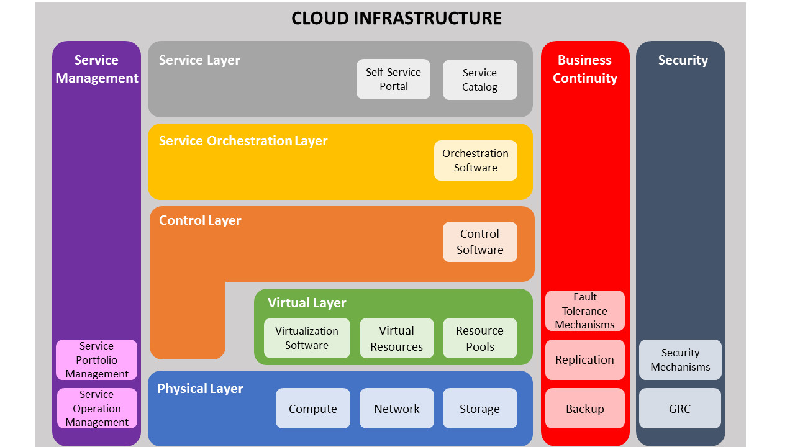activities into five logical layers and three cross-layer functions.

The five layers are physical layer, virtual layer, control layer, service orchestration layer, and service layer. Each of these layers specifies various types of entities that may exist in a cloud computing environment, such as compute systems, network devices, storage devices, virtualization software, security mechanisms, control software, orchestration software, management software, and so on. It also describes the relationships among these entities.

The three cross-layer functions are business continuity, security, and service management. Business continuity and security functions specify various activities, tasks, and processes that are required to offer reliable and secure cloud services to the consumers. Service management function specifies various activities, tasks, and processes that enable the administrations of the cloud infrastructure and services to meet the provider’s business requirements and consumer’s expectations

## Cloud computing layers

**Physical Layer**

* Foundation layer of the cloud infrastructure.
* Specifies entities that operate at this layer : Compute systems, network devices and storage devices. Operating environment, protocol, tools and processes.
* Functions of physical layer : Executes requests generated by the virtualization and control layer.

**Virtual Layer**

* Deployed on the physical layer.
* Specifies entities that operate at this layer : Virtualization software, resource pools, virtual resources.
* Functions of virtual layer : Abstracts physical resources and makes them appear as virtual resources (enables multitenant environment). Executes the requests generated by control layer.

**Control Layer**

* Deployed either on virtual layer or on physical layer
* Specifies entities that operate at this layer : control software
* Functions of control layer : Enables resource configuration, resource pool configuration and resource provisioning. Executes requests generated by service layer. Exposes resources to and supports the service layer. Collaborates with the virtualization software and enables resource pooling and creating virtual resources, dynamic allocation and optimizing utilization of resources.

**Service Orchestration Layer**

* Specifies the entites that operate at this layer : Orchestration software.
* Functions of orchestration layer : Provides workflows for executing automated tasks. Interacts with various entities to invoke provisionning tasks.

**Service Layer**

* Consumers interact and consume cloud resources via thos layer.
* Specifies the entities that operate at this layer : Service catalog and self-service portal.
* Functions of service layer : Store information about cloud services in service catalog and presents them to the consumers. Enables consumers to access and manage cloud services via a self-service portal.

**Cross-layer function**

**Business continuity**

* Specifies adoption of proactive and reactive measures to mitigate the impact of downtime.
* Enables ensuring the availability of services in line with SLA.
* Supports all the layers to provide uninterrupted services.

**Security**

* Specifies the adoption of : Administrative mechanisms (security and personnel policies, standard procedures to direct safe execution of operations) and technical mechanisms (firewall, intrusion detection and prevention systems, antivirus).
* Deploys security mechanisms to meet GRC requirements.
* Supports all the layers to provide secure services.

**Q2. Describe the NIST cloud computing reference architecture major players.**

**Ans :-** In September 2011, The National Institute for Standard and Technology (NIST) created Special Publication (SP) 500-292, “NIST Cloud Computing Reference Architecture,” to establish a baseline cloud computing architecture. NIST SP 500-292 defines services and relationships between cloud service providers, consumers, and other stakeholders. When preparing to implement or revisit your cloud computing architecture, you’ll want to review the specifics of NIST SP 500-292.

The NIST SP 500-292 breaks down into several sections that define and explain all elements of [cloud computing](https://www.rsisecurity.com/cloud-security/). These form a taxonomy with four distinct levels, each representing a more nuanced, niche set of terms. The first two levels define the most essential terms:

* **The Level 1 terms** – A set of Roles that collectively comprise the cloud Reference Model
* **The Level 2 terms** – A set of Activities that define the model’s Architectural Components

The first portion of NIST SP 500-292 defines the relationships between all stakeholders involved in [cloud computing](https://blog.rsisecurity.com/the-essential-characteristics-of-cloud-computing/). There are five major roles detailed within NIST SP 500-292:

* Cloud Consumer
* Cloud Provider
* Cloud Auditor
* Cloud Broker
* Cloud Carrier

**1.Cloud Consumer =**Software as a service (SaaS) consumers who rely on cloud computing for general office or productivity services (e.g., HR and accounting tasks)

* Platform as a service (PaaS) consumers who rely on cloud computing for their business intelligence needs (e.g., database management and application integration)
* Information technology as a service (ITaaS) consumers who rely on cloud computing for IT needs (e.g., storage, backups, content delivery, and other general computing tasks)

**2.Cloud Provider=**Cloud providers are the parties most closely associated with cloud consumers. They are responsible for making cloud services available. Cloud providers’ offerings correspond to the types of consumers, along with the “Activities” or “Components.”

SaaS cloud providers generally deploy or manage the configuration of given software on cloud infrastructure. PaaS cloud providers generally manage the cloud infrastructure while also developing tools for optimizing workflows. ITaaS cloud providers generally facilitate distribution, maintenance, and monitoring of cloud infrastructure.

**3.Cloud Auditor=**The NIST defines cloud auditors as parties who can execute independent audits or assessments on a company’s cloud infrastructure. Audits are typically done to determine whether the infrastructure meets cybersecurity or compliance benchmarks. Critically, auditing services must be delivered separately from any cloud services when partnering with the same vendor or by another third party.

**4.Cloud Broker=**Cloud brokers are defined as *managing* service providers. Consumers may contact cloud brokers instead of cloud providers. Brokers tend to handle three cloud categories:

* **Intermediation** – Enhancing access, performance monitoring, identity management, etc.
* **Aggregation** – Integrating a provider’s cloud services into a comprehensive cloud suite
* **Arbitrage** – Integrating services from *multiple* providers into a uniform service suite

**5.Cloud Carrier=**The NIST defines cloud carriers as the parties facilitating consumers’ and providers’ data transmissions and their connectivity to cloud services.

Cloud carriers’ responsibilities include the production and distribution of all physical and virtual resources needed to maintain cloud computing. Responsibilities pertain to all the servers and hardware needed to keep cloud networks up and running, along with endpoints or network access devices used to access cloud data safely.

**COMPONENT:**

* **Public** – Most cloud infrastructure and resources are available or accessible to a diverse audience, including the general public and a wide range of subscription-level consumers.
* **Private** – The cloud infrastructure and resources are available or accessible to only an individual consumer. These are hosted on-site by the provider or off-site by a third party.
* **Community** – Most cloud infrastructure and resources are available or accessible to a group of consumers within the same industry or with similar security needs or concerns.
* **Hybrid** – Cloud infrastructure and resources are available via distinct, packaged distribution models (e.g., through a cloud broker).

**Q3. What are NIST service models? Discuss the advantage and disadvantage of each service model.**

**Ans :-**There is confusion around the three main categories of [cloud service models](https://www.siriuscom.com/solutions/cloud/): Infrastructure as a Service (IaaS), Platform as a Service (PaaS) and Software as a Service (SaaS). Let’s define each cloud service model.

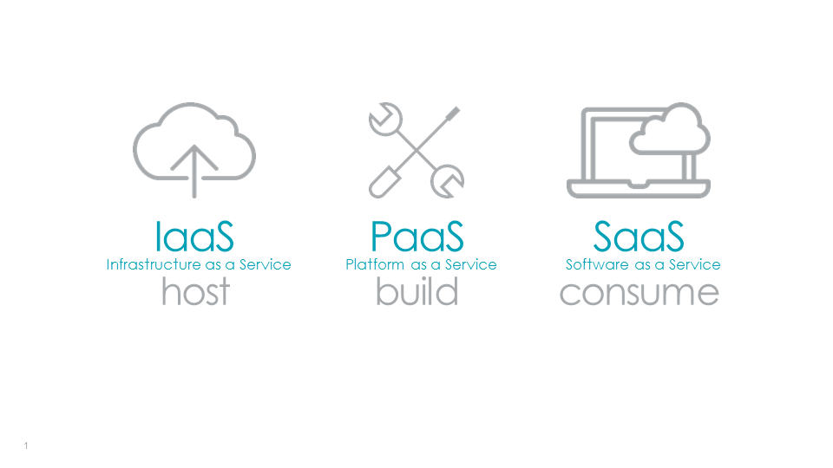

**Infrastructure as a Service (IaaS)**

Infrastructure as a Service (IaaS) is a self-service model for managing remote data center infrastructures. IaaS provides virtualized computing resources over the Internet hosted by a third party such as Amazon Web Services, Microsoft Azure or Google. Instead of an organization purchasing hardware, companies purchase IaaS based on a consumption model. It is like buying electricity. You only pay for what you use. This model enables companies to add, delete or reconfigure IT infrastructure on-demand. Many IT organizations rely on IaaS because they are more familiar with IaaS, especially if they have years of experience with virtual environments or strict security and regulatory requirements that can only be met through IaaS.

**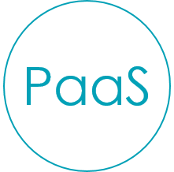Platform as a Service (PaaS)**

Platform as a Service (PaaS) allows organizations to build, run and manage applications without the IT infrastructure. This makes it easier and faster to develop, test and deploy applications. Developers can focus on writing code and create applications without worrying about time-consuming IT infrastructure activities such as provisioning servers, storage and backup. PaaS brings more value to cloud. It can reduce your management overhead and lower your costs. PaaS also makes it easier for you to innovate and scale your services on demand.

**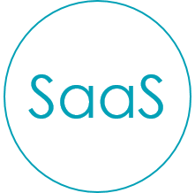Software as a Service (SaaS)**

Software as a service (SaaS) replaces the traditional on-device software with software that is licensed on a subscription basis. It is centrally hosted in the cloud. A good example is Salesforce.com. Most SaaS applications can be accessed directly from a web browser without any downloads or installations required. However, some SaaS applications require plugins.

**DISADVANTAGE:**

* Software as a Service (SaaS) which are web-based applications accessible by client devices such as web browsers. With the SaaS model the consumer does not manage or control the underlying cloud infrastructure hardware or Operating System (OS), storage, or many of the individual application capabilities . The application SalesForce is an example of SaaS where the client has access to just the application but none of the underlying infrastructure or settings [(SalesForceSaaS, n.d.)](https://www.salesforce.com/saas/).
* Platform as a Service (PaaS) is a cloud model where the consumer does not manage or control the underlying cloud infrastructure such as hardware, OS, and network devices, but has control over its deployed applications and many configuration settings for application-hosting . Paasify.it vendors (n.d.) provides a comparison list of many reputable PaaS vendors.
* Infrastructure as a Service (IaaS) is a model where the consumer does not manage or control the underlying cloud infrastructure, but does have control over operating systems, storage, and deployed applications . [Amazon EC2](https://aws.amazon.com/ec2/" \t "_blank) is a well-known cloud service that provides virtual environments which allow customers control over software, storage, and configurations [(Amazon EC2, n.d.)](https://aws.amazon.com/ec2/).

**Advantages of SaaS :**

1.**Cost Effective :** Pay only for what you use  
2.**Reduced time :** Users can run most SaaS apps directly from their web browser without needing to download and install any software.This reduces the time spent in installation and configuration, and can reduce the issues that can get in the way of the software deployment.  
3.**Accessibility :** We can Access app data from anywhere.  
4.**Automatic updates :** Rather than purchasing new software, customers rely on a SaaS provider to automatically perform the updates.  
5.**Scalability :**It allows the users to access the services and features on demand.

**Advantages of PaaS :**

1.**Simple and convenient for users :**It provides much of the infrastructure and other IT services, which users can access anywhere via a web browser.  
2.**Cost Effective :**It charges for the services provided on a per-use basis thus eliminating the expenses one may have for on-premises hardware and software.  
3.**Efficiently managing the lifecycle :** It is designed to support the complete web application lifecycle: building, testing, deploying, managing and updating.  
4.**Efficiency :** It allows for higher-level programming with reduced complexity thus, the overall development of the application can be more effective

**Advantages of IaaS :**

1.**Cost Effective :** Eliminates capital expense and reduces ongoing cost and IaaS customers pay on a per use basis, typically by the hour, week or month.  
2.**Website hosting :** Running websites using IaaS can be less expensive than traditional web hosting.  
3.**Security :**The IaaS Cloud Provider may provide better security than your existing software.  
4.**Maintainence :** There is no need to manage the underlying data center or the introduction of new releases of the development or underlying software. This is all handled by the IaaS Cloud Provider.

**Q4.What are the different types of cloud. Explain their advantage and disadvantage.**

Ans:-**Cloud Computing**means storing and accessing data or applications over the Internet. This can be done in three ways

**1) Public Cloud Computing**

**2) Private Cloud Computing**

**3) Hybrid cloud Computing.**

## Types of Cloud Deployment

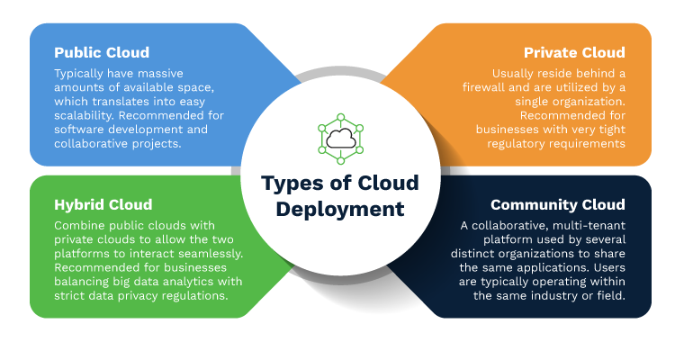

**1.Public Cloud:**

A cloud platform that is based on standard cloud computing model in which service provider offers resources, applications storage to the customers over the internet is called as public cloud computing. The hardware resources in public cloud are shared among similar users and accessible over a public network such as the internet. Most of the applications that are offered over internet such as Software as a Service (SaaS) offerings such as cloud storage and online applications uses Public Cloud Computing platform. Budget conscious startups, SMEs not keen on high level of security features looking to save money can opt for Public Cloud Computing.

**Advantage of Public Cloud Computing**

1. It offers greater scalability

2. Its cost effectiveness helps you save money.

3. It offers reliability which means no single point of failure will interrupt your service.

4. Services like SaaS, (Paas), (Iaas) are easily available on Public Cloud platform as it can be accessed from anywhere through any Internet enabled devices.

5. It is location independent – the services are available wherever the client is located.

**Disadvantage of Public Cloud Computing**

1. No control over privacy or security

2. Cannot be used for use of sensitive applications

3. Lacks complete flexibility as the platform depends on the platform provider

4. No stringent protocols regarding data management

**2.Private Cloud:**

A cloud platform in which a secure cloud based environment with dedicated storage and hardware resources provided to a single organization is called Private Cloud Computing. The Private cloud can be either hosted within the company or outsourced to a trusted and reliable third-party vendor. It offers company a greater control over privacy and data security. The resources in case of private cloud are not shared with others and hence it offer better performance compared to public cloud. The additional layers of security allow company to process confidential data and sensitive work in the private cloud environment.

**Advantage of Private Cloud Computing**

1. Offers greater Security and Privacy

2. Offers more control over system configuration as per the company’s need

3. Greater reliability when it comes to performance

4. Enhances the quality of service offered by the clients

5. Saves money

**Disadvantage of Private Cloud**

1. Expensive when compared to public cloud

2. Requires IT Expertise

**3.Hybrid Cloud:**

Hybrid Cloud computing allows you to use combination of both public and private cloud. This helps companies to maximize their efficiency and deliver better performance to clients. In this model companies can use public cloud for transfer of non-confidential data and switch on to private cloud in case of sensitive data transfer or hosting of critical applications. This model is gaining prominence in many business as it gives benefits of both the model.

**Advantage of Hybrid Cloud Computing**

1. It is scalable

2. It is cost efficient

3. Offers better security

4. Offers greater flexibility

**Disadvantage of Hybrid Cloud Computing**

1. Infrastructure Dependency

2. Possibility of security breach through public cloud

**Ques-5. What is cloud interoperability? Explain the view and need of Interoperability.**

**Ans:-Interoperability:** Interoperability is the capacity of at least two applications or systems to trade data and to utilize the data that has been traded commonly. Cloud interoperability is the capacity of a client’s framework to interface with a cloud service or the capacity for one cloud service to connect with other cloud benefits by trading data as per an endorsed strategy to get unsurprising outcomes.

The two important elements of Cloud interoperability are usability and connectivity and have been separated into 5 layers:

1. Behaviour
2. Policy
3. Semantic
4. Syntactic
5. Transport

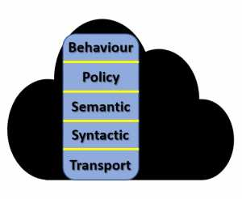

**Portability:** Portability, then again, is moving the applications or data starting with one framework then onto the next and having it stay executable or useable. Portability can be broken into two kinds: Cloud data portability and Cloud application portability.

1. **Cloud data portability:** It is the capacity to effectively move information starting with one cloud service then onto the next without expecting to re-emerge the information.
2. **Cloud application portability:** It is the capacity to move an application starting with one cloud service then onto the next or between a client’s current circumstance and a cloud service.

**2) CLOUD PORTABILITY AND INTEROPERABILITY CATEGORIES TO CONSIDER ARE:**

1. Publication and Acquisition Interoperability
2. Management Interoperability
3. Platform Interoperability
4. Application Interoperability
5. Platform Portability
6. Application Portability
7. Data Portability

**3) PROBLEMS & SOLUTIONS**

The principle challenge organizations going for cloud interoperability issues is the sheer assortment of cloud APIs and interfaces, as per the Cloud Standards Customer Council paper. They aren’t normalized, and cloud service organizations utilize various ones.

Cloud infrastructure administrations have a more elevated level of cloud interoperability because their administrations are practically identical, and there are some standard interfaces.

Developer driven stage as administration contributions is less interoperable because a couple of interface guidelines exist. SaaS application, with significantly less standard APIs, “presents the best interoperability challenge today,” the Cloud Standards Customer Council paper proceeded.

As a solution/answer to these issues, organizations can assemble a “Mapping Layer” between their own frameworks’ cloud services’ Application Programming Interface and Application Programming Interface utilizing an enterprise service bus or on the other hand, they can utilize a cloud service dealer, “which does that mapping for you.”

The greatest difficulties disrupting the general flow of utilization movability are for Platform-as-a-Service built applications. That is because Platform-as-a-Service stages generally fluctuate; for instance, how one stage oversees information may not be upheld at all in another. The cloud interoperability challenges in every one of the cloud services classes SaaS, PaaS and IaaS will be unique.

Organizations attempting to move data starting with one cloud infrastructure then onto the next are in an ideal situation since guidelines that take into account moving applications do exist. Standard OS, for example, Linux, can help to move data. An open-source stage, for example, Cloud Foundry, can help to migrate data among Platform-as-a-Service frameworks and container innovation; for example, Docker can help move bits of applications.

A few standards organizations have been striving to explain, qualify and define the elements of cloud interoperability and standards & cloud portability and standards. The objective is a more open cloud computing that limits the risk of merchant hindrances and maintains a strategic distance from the shortcomings of contradictory administrations.

**Several Standards Organizations are:**

1. The European Telecommunications Standards Institute.
2. The National Institute of Standards and Technology.
3. The Institute of Electrical and Electronics Engineers.
4. The International Organization for Standardization.
5. International Telecommunications Union – Telecommunications Sector.
6. Cloud Standards Customer Council.

## Que-6 .****What is cloud scalability? Explain the things that ensures cloud scalability is efficient.****

## ****Ans:-**Cloud scalability** in cloud computing refers to the ability to increase or decrease IT resources as needed to meet changing demand. Scalability is one of the hallmarks of the cloud and the primary driver of its exploding popularity with businesses.

**1.Avoid the single point of failure.** We can never just have **one** of anything, we should always assume and design for having at least two of everything. This adds costs in terms of additional operational effort and complexity, but we gain tremendously in terms of availability and performance under load. Also, it forces us into a distributed-first mindset. has been said by various people, and it’s very true.

**2.Scale horizontally, not vertically.** There is a limit to how large a single server can be, both for physical and virtual machines. There are limits to how well a system can scale horizontally, too. That limit, though, is increasingly being pushed further ahead.

**3.Push work as far away from the core as possible.** There are several orders of magnitude more clients than servers as we move inward into the core of our application. The less work the few have to do on behalf of the many, the better. The smaller the updates we can pass to our clients, the better.

**4.API first.** In addition to pushing work to the clients, view your application as a service with an API first. Clients these days are smartphone apps, web sites with JavaScript, and desktop applications. If the API does not make assumptions about which clients will connect to it, it will be able to serve all of them. And you open your service up for automation, as well.

**5.Cache everything, always.**Caches are essentially storages of precomputed results that we use to avoid computing the results over and over again. This is a Godsend for scalability and performance, so we must use it.

**6.Provide as fresh asneeded data.**Depending on your application, users might not need the very freshest data right away. Eventual consistency leads to much better availability under the CAP theorem. If we actually need strict consistency, so be it.

**7.Design for maintenance and automation.**Software needs monitoring and updates to ensure proper operation over time. As we move out of the era and into the era, our mindset has to change. Do we even need to reconfigure servers anymore? Can’t we just take old ones down and replace with new ones, that have been configured offline as part of their image creation? What monitoring data is important to us?  Do not under-estimate the time and effort spent in maintaining your application. Your initial public software release is a laudable milestone, it also marks when the **real** work begins.

**8.Asynchronous rather than synchronous.**We already understand asynchronous communication perfectly in the physical world. We drop off a letter in the mail, and some time later, it arrives. Until it does, we convince ourselves that it is underway, oblivious to the complexity of the postal system. We only use personal couriers for very important messages. A similar approach should be taken for our applications. Did a user just hit submit? Tell the user that the submission went well, and then process it in the background. Perhaps show the update as if it is already completely done in the mean time.

**9.Strive for statelessness.** While it may seem tempting to avoid inter-component communication by keeping track of certain state information in e.g. your application servers, don’t. Unless we host purely static pages, we can never get away from state information. We must make sure that state information is kept in as few places as possible, and within components made for it. Web and application servers are not, but distributed key-value stores are. Keeping it there lets you treat your web and application servers as completely replaceable instances, which is ideal from a scalability point of view since your server fleet can much more easily be modified when any server is able to handle any client request (despite the client being in the midst of a “session”).

**10.This too shall fail.** Computer systems fail. Software fails. Hardware fails. Designs fail. Failure handling fails! Be prepared for failure, but spare end users from witnessing it too obviously. It reflects poorly on you, even if failure is inevitable.

## Ques-7. What do u mean by fault tolerance? Discuss the challenges of fault tolerance in cloud computing.

## Ans:-Fault tolerance refers to the ability of a system (computer, network, cloud cluster, etc.) to continue operating without interruption when one or more of its components fail. ... Fault-tolerant systems use backup components that automatically take the place of failed components, ensuring no loss of service.

**Challenges of Implementing Fault Tolerance in Cloud Computing :-**

* Providing fault tolerance requires careful consideration and analysis because of their complexity, inter-dependability and the following reasons.

•There is a need to implement autonomic fault tolerance technique for multiple instances of an application running on several virtual machines.

•Different technologies from competing vendors of cloud infrastructure need to be integrated for establishing a reliable system .

•The new approach needs to be developed that integrate these fault tolerance techniques with existing workflow scheduling algorithms.

•A benchmark based method can be developed in cloud environment for evaluating the performances of fault tolerance component in

comparison with similar ones.

•To ensure high reliability and availability multiple clouds computing providers within independent software stacks should be used .

•Autonomic fault tolerance must react to synchronization among various clouds.

**Ques-8. What do u mean by cloud analytics. Explain the key elements of cloud analytics.**

**Ans:-**Cloud analytics **describes the application of analytic algorithms in the cloud against data in a private or public cloud to then deliver a result of interest**. Cloud analytics involves deployment of scalable cloud computing with powerful analytic software to identify patterns in data and to extract new insights.

**KEY ELEMENTS:-**

### 1.Data Sources

Without data, there is no analytics to speak of. To equip your business with the intel and insights it needs to gain a competitive edge, you need to have a robust, [useful pool of data](https://simplicable.com/new/business-data) to draw from. When it comes to business analytics, any business operation is fair game, regardless of whether you’re working with a cloud analytics software service or an on-premise service.

The critical difference in data sources for cloud analytics is that it’s all stored and delivered via the cloud. A cloud solution offers you the ability to have access to your real-time data at any time, just hosted, warehoused and stored off-premise. An on-premise solution means that your data is slow and subject to being out-of-date when your intel updates. Imagine your sales team losing a sale because they didn’t have proper customer intel when they needed it, or marketing’s campaign fails because they were also out-of-date. With the cloud, data is accessible and current so long as there is an internet connection.

### 2. Data Models

[Data models](https://cedar.princeton.edu/understanding-data/what-data-model) refer to how clusters of data elements are organized and how they relate to their real-world counterparts. For example, a car could be a data model, as it has hundreds, if not thousands of potential data points that comprise the car as an entity.

Looking for how data models relate to the cloud? Cloud data models are capable of learning based on constantly updating data pools. Better yet, a cloud solution comes equipped with progressive models, applications, uploads and more. You won’t have to spend any time building out your own for your own uses, and if you do, you can add the models yourself.

### 3. Processing Applications

When you’ve got all the data you could ask for, what do you do with it? When you catch a fish for dinner, you need to clean and “prepare” the fish first. The same is true for data — it needs to be properly prepared before being used. In terms of a cloud solution, your processing application is up in the cloud, often managed and maintained by your third-party vendor, which means you can process data faster than you could with a self-installed and on-premise system. It’s more readily available too.

Your processing application is always on and always ready to crunch data for you. An on-site solution might not be accessible in a consistent way, meaning that you’re as slow as you can retrieve processed data from it. Which brings us to our next point: computing power.

### 4. Cloud-Based Computing Power

When it comes to your cloud solution, computing power is a big deal. In order to process a ton of data in a reasonable amount of time, a decent hardware stack is needed. A local solution could end up becoming your biggest bottleneck, as well as price-sink. If you don’t have the right hardware, you might find yourself waiting for data to be processed and parsed, tempted to upgrade your hardware and or waste your IT team’s time having them babysit your custom analytics build.

A cloud solution means all of your data processing happens off-site on highly specialized [cluster computers](https://www.techopedia.com/definition/6581/computer-cluster) owned by your vendor. Your data is ready and processed within minutes and is available to you wherever there is a network. This takes a significant burden off of your agency as having adequate computing power is no longer a priority for you, nor a budgetary concern.

### 5. Analytics Models

Analytics models, according to [Search business analytics](https://searchbusinessanalytics.techtarget.com/opinion/Analytical-modeling-is-both-science-and-art), are mathematical and statistical equations that help describe trends and interesting points of data. They are the backbone to business analytics, as they help pull abstract plots of data into more cohesive and understandable terms, even if those terms still have to be mathematically translated.

A cloud analytics program is “always on” and thus always has access to the latest and greatest models that the vendor can create. This is a distinct advantage for cloud data analytics — the models are always being updated and managed by someone else. Most cloud analytics software will have models that should cover 95 percent of your business needs, taking a significant burden off of your agency. In an ideal setting, you won’t ever have to come up with your own complex data models to parse data — at least, that’s what cloud analytics seeks to do.

### 6. Warehousing and Storage

All that data has to end up somewhere, doesn’t it? And if you plan on keeping data around for long-term analysis, then you might need to think carefully about where and how it’s going to be stored. Sure, storage can be cheap, but retrieval isn’t always cheap or efficient, and long term storage might become yet another headache for your IT department.

A cloud solution solves all of those problems for you. It’s managed by a third party (and not by your already over-booked IT department), allows you to store petabytes worth of information, and costs less than a penny per gigabyte to retrieve. Cloud data analytics takes the burden off your company for storing and maintaining its own pools of data. They also make it more readily accessible and provide that data on multiple platforms in combination with their own powerful data models.

One con is that your data is in the hands of someone else. If that service disappears or suffers a service interruption, your data will be lost until the service is brought back online or it can be retrieved. In a sense, you have to pick your poison; store data in the cloud and leave it up to someone else to manage, or stash it yourself but [incur a sizeable cost](https://www.nasuni.com/the-hidden-costs-of-file-storage-revealed-in-new-infographic/) depending on how much you plan on storing. However, inquiring about your vendor’s uptime may make this an easier decision.

**Q9. What are the cloud offerings? Discuss the benefits of cloud offering**

**Ans:-**Cloud Offerings :-

#### Make your Business More Agile and Efficient

**Our Cloud-based services help the businesses to access cloud-based infrastructure that is assured with security, reliability, scalability, and availability.**

**We provide these services which can help organizations to manage their business from anywhere and anytime and offer unbreakable service to their customers.**

**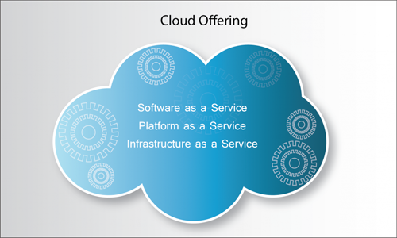**

**Our comprehensive cloud-based IT offerings include Software as a Service (SaaS), Platform as a Service (PaaS), Infrastructure as a Service (IaaS) and Test Environment as a Service (TEaaS). These cloud offerings enable organizations to reduce overall IT costs in multiple ways and reap maximum value from the offering.**

## Cloud Offering Benefits

**Infotree’s comprehensive cloud offerings can help organizations to reap maximum benefits over the in-house infrastructure and software.**

**• Reduce Operational Costs and Capital Expenditures**

**• Improve Accessibility**

**• Improve Flexibility**

**• Deploy Projects Faster**

**• Business Agility**

**• Easily Adapt to Changing Resource Demands**

**• Pay for what you use**

**• Expedite Time-To-Market**

**• Better use of Resources**

**• Leverage Private, Public, and Hybrid Cloud Solutions as Needed**

**• Assure Stability, Scalability, Security, Maintenance and Monitoring of Cloud Environments**

**Q10.Explain the different cloud analytics services.**

**Ans :-**Cloud analytics makes it much easier to implement, manage and access analytics for all users. Companies and organizations no longer need to worry about costly infrastructure or update software, while individuals have the ease of access from any approved device. As a result more focus is on the insights from analytics to make better business decisions.

**Different Type of cloud analytics servies**

Cloud analytics shifts analytics and BI processing from on-premise servers to cloud networks, and can be deployed in a variety of ways.

Our technology works with your infrastructure

Public cloud: Services are shared by multiple companies, but each company’s data and applications are hidden from each other. Companies choose this option to get benefits like higher performance or manageability, while keeping costs down.

Private cloud: Usually behind a firewall, private cloud services and hardware are dedicated to one company. Organizations with highly sensitive data, such as banks or medical organizations, may choose a private cloud for increased security.

Hybrid: A mixture of private and public clouds, companies that choose hybrid deployments get the best of both worlds. They can keep highly sensitive data in a private cloud while moving less sensitive data to a public cloud at a lower cost.

Hybrid and Multi-cloud: Many organizations use a mixture of different Public, Private and even on-premises approaches to optimize security, scalability and total cost of ownership. Best-in-class analytics solutions embrace this approach so organizations can choose which data is stored where and where analytics occurs.

**Q11. Explain the cloud testing under control.**

**Ans :-Testing Under Control:**

Cloud testing typically involves monitoring and reporting on real-world user traffic conditions as well as load balance and stress testing for a range of simulated usage conditions.

Load and performance testing conducted on the applications and services provided via cloud computing particularly the capability to access these services in order to ensure optimal performance and scalability under a wide variety of conditions.

Consumers can access the IT resources in the test environment.

Testing under the cloud gives very good sign by decreasing the manual intervention and reducing the processes in the typical testing environment.

After enabling of resources as and when they are required ,it reduces the investment on capital as well as enables the business to handle the ups and downs of the testing requirements.

**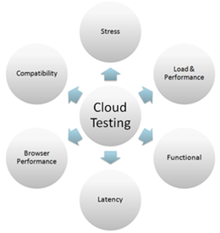**

**Facts under cloud computing**

The fig clearly shows that on the basis of these six parameters a cloud testing process can be performed.

**Advantages of Cloud Testing:**

Reduces capital investment and operational costs and not effect goal critical production application.

Offers new and attractive services to the clients and present an opportunity to speed cycles of innovations and improve the solution quality.

**Q12.What is virtual desktop infrastructure? Discuss its different types of virtualization.**

**Ans :-Virtualization uses software to create an abstraction layer over computer hardware that allows the hardware elements of a single computer—processors, memory, storage and more—to be divided into multiple virtual computers, commonly called virtual machines (VMs). Each VM runs its own operating system (OS) and behaves like an independent computer, even though it is running on just a portion of the actual underlying computer hardware.**

**It follows that virtualization enables more efficient utilization of physical computer hardware and allows a greater return on an organization’s hardware investment.**

**Today, virtualization is a standard practice in enterprise IT architecture. It is also the technology that drives** [**cloud computing**](https://www.ibm.com/cloud/learn/cloud-computing-gbl) **economics. Virtualization enables cloud providers to serve users with their existing physical computer hardware; it enables cloud users to purchase only the computing resources they need when they need it, and to scale those resources cost-effectively as their workloads grow.**

## Types of virtualization

**To this point we’ve discussed server virtualization, but many other IT infrastructure elements can be virtualized to deliver significant advantages to IT managers (in particular) and the enterprise as a whole. In this section, we'll cover the following types of virtualization:**

* **Desktop virtualization**
* **Network virtualization**
* **Storage virtualization**
* **Data virtualization**
* **Application virtualization**
* **Data center virtualization**
* **CPU virtualization**
* **GPU virtualization**
* **Linux virtualization**
* **Cloud virtualization**

### Desktop virtualization

Desktop virtualization lets you run multiple desktop operating systems, each in its own VM on the same computer.

There are two types of desktop virtualization:

* Virtual desktop infrastructure (VDI) runs multiple desktops in VMs on a central server and streams them to users who log in on thin client devices. In this way, VDI lets an organization provide its users access to variety of OS's from any device, without installing OS's on any device. See "[What is Virtual Desktop Infrastructure (VDI)?](https://www.ibm.com/cloud/blog/what-is-virtual-desktop-infrastructure)" for a more in-depth explanation.
* Local desktop virtualization runs a hypervisor on a local computer, enabling the user to run one or more additional OSs on that computer and switch from one OS to another as needed without changing anything about the primary OS.

For more information on virtual desktops, see “[Desktop-as-a-Service (DaaS)](https://www.ibm.com/cloud/learn/desktop-as-a-service).”

### Network virtualization

Network virtualization uses software to create a “view” of the network that an administrator can use to manage the network from a single console. It abstracts hardware elements and functions (e.g., connections, switches, routers, etc.) and abstracts them into software running on a hypervisor. The network administrator can modify and control these elements without touching the underlying physical components, which dramatically simplifies network management.

Types of network virtualization include software-defined networking (SDN), which virtualizes hardware that controls network traffic routing (called the “control plane”), and network function virtualization (NFV), which virtualizes one or more hardware appliances that provide a specific network function (e.g., a firewall, [load balancer](https://www.ibm.com/cloud/learn/load-balancing), or traffic analyzer), making those appliances easier to configure, provision, and manage.

### Storage virtualization

Storage virtualization enables all the storage devices on the [network](https://www.ibm.com/cloud/learn/networking-a-complete-guide)— whether they’re installed on individual servers or standalone storage units—to be accessed and managed as a single storage device. Specifically, storage virtualization masses all blocks of storage into a single shared pool from which they can be assigned to any VM on the network as needed. Storage virtualization makes it easier to provision storage for VMs and makes maximum use of all available storage on the network.

For a closer look at storage virtualization**,** check out "[What is Cloud Storage?](https://www.ibm.com/cloud/learn/cloud-storage)**"**

### Data virtualization

Modern enterprises store data from multiple applications, using multiple file formats, in multiple locations, ranging from the cloud to on-premise hardware and software systems. Data virtualization lets any application access all of that data—irrespective of source, format, or location.

Data virtualization tools create a software layer between the applications accessing the data and the systems storing it. The layer translates an application’s data request or query as needed and returns results that can span multiple systems. Data virtualization can help break down data silos when other types of integration aren’t feasible, desirable, or affordable.

### Application virtualization

Application virtualization runs application software without installing it directly on the user’s OS. This differs from complete desktop virtualization (mentioned above) because only the application runs in a virtual environment—the OS on the end user’s device runs as usual. There are three types of application virtualization:

* Local application virtualization: The entire application runs on the endpoint device but runs in a runtime environment instead of on the native hardware.
* Application streaming: The application lives on a server which sends small components of the software to run on the end user's device when needed.
* Server-based application virtualization The application runs entirely on a server that sends only its user interface to the client device.

### Data center virtualization

Data center virtualization abstracts most of a data center’s hardware into software, effectively enabling an administrator to divide a single physical data center into multiple virtual data centers for different clients.

Each client can access its own infrastructure as a service (IaaS), which would run on the same underlying physical hardware. Virtual data centers offer an easy on-ramp into cloud-based computing, letting a company quickly set up a complete data center environment without purchasing infrastructure hardware.

### CPU virtualization

CPU (central processing unit) virtualization is the fundamental technology that makes hypervisors, virtual machines, and operating systems possible. It allows a single CPU to be divided into multiple virtual CPUs for use by multiple VMs.

At first, CPU virtualization was entirely software-defined, but many of today’s processors include extended instruction sets that support CPU virtualization, which improves VM performance.

### GPU virtualization

A GPU (graphical processing unit) is a special multi-core processor that improves overall computing performance by taking over heavy-duty graphic or mathematical processing. GPU virtualization lets multiple VMs use all or some of a single GPU’s processing power for faster video, artificial intelligence (AI), and other graphic- or math-intensive applications.

* Pass-through GPUs make the entire GPU available to a single guest OS.
* Shared vGPUsdivide physical GPU cores among several virtual GPUs (vGPUs) for use by server-based VMs.

### Linux virtualization

Linux includes its own hypervisor, called the kernel-based virtual machine (KVM), which supports Intel and AMD’s virtualization processor extensions so you can create x86-based VMs from within a Linux host OS.

As an open source OS, Linux is highly customizable. You can create VMs running versions of Linux tailored for specific workloads or security-hardened versions for more sensitive applications.

### Cloud virtualization

As noted above, the cloud computing model depends on virtualization. By virtualizing servers, storage, and other physical data center resources, cloud computing providers can offer a range of services to customers, including the following:

* [Infrastructure as a service (IaaS)](https://www.ibm.com/cloud/learn/iaas):Virtualized server, storage, and network resources you can configure based on their requirements.
* [Platform as a service (PaaS)](https://www.ibm.com/cloud/learn/paas): Virtualized development tools, databases, and other cloud-based services you can use to build you own cloud-based applications and solutions.
* Software as a service (SaaS): Software applications you use on the cloud. SaaS is the cloud-based service most abstracted from the hardware.

If you’d like to learn more about these cloud service models, see our guide: “[**IaaS vs. PaaS vs. SaaS**](https://www.ibm.com/cloud/learn/iaas-paas-saas)**.”**